**Pages**

1. Login/Register
2. Student
   1. Student Page
3. Teacher
   1. Course Manager
   2. Programs
   3. Student, profile pages
4. Admin
   1. Course Manager and Teacher Manager
   2. Same as Teacher

Login Page

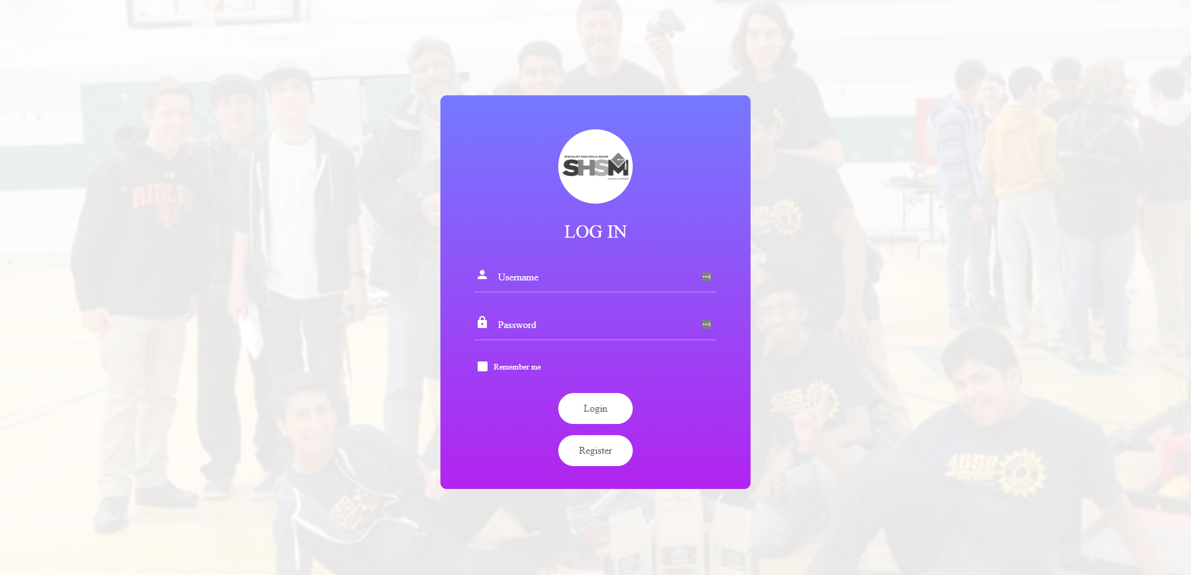

Register

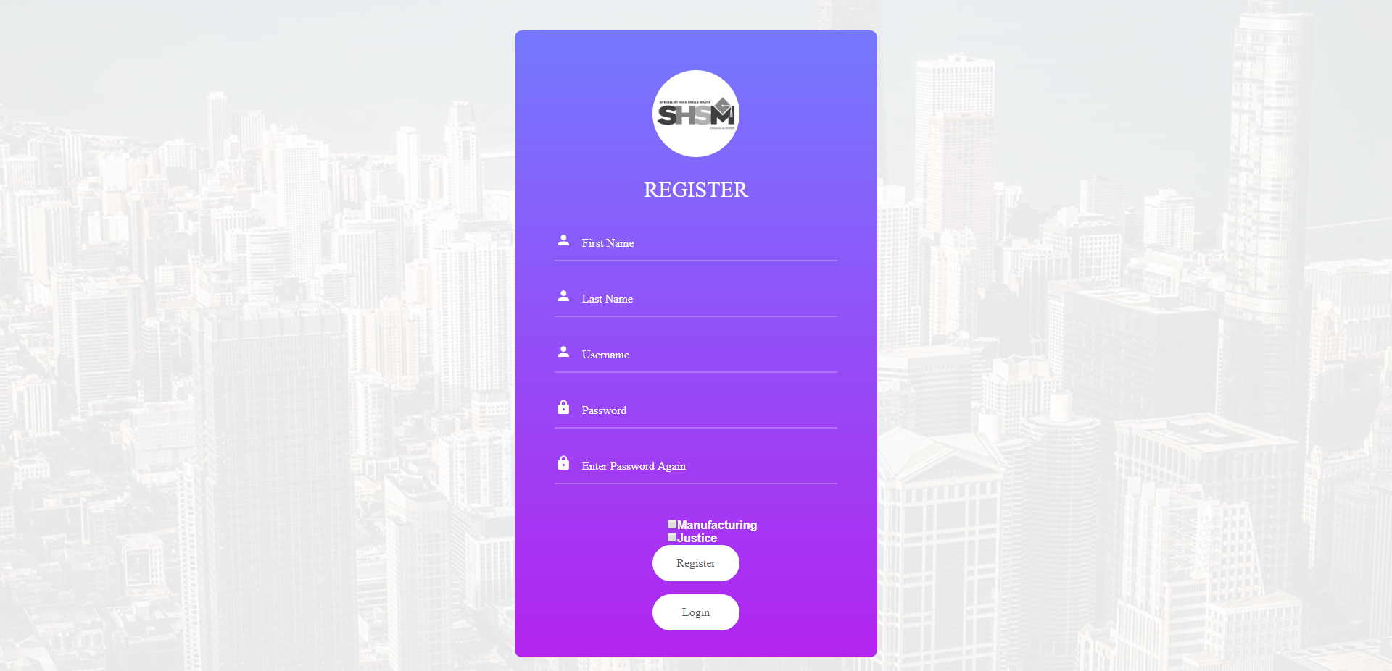

Student

The student page shows the student all the data that they require, it provides information that indicates their progress on completing their SHSM program and provides mechanisms to alter this data.

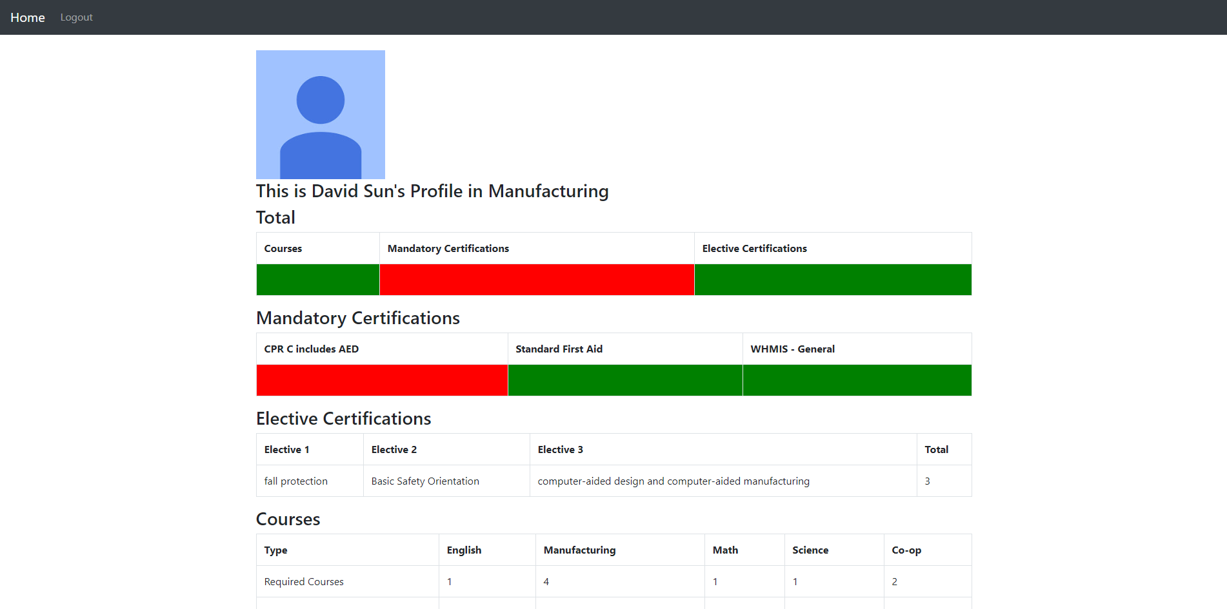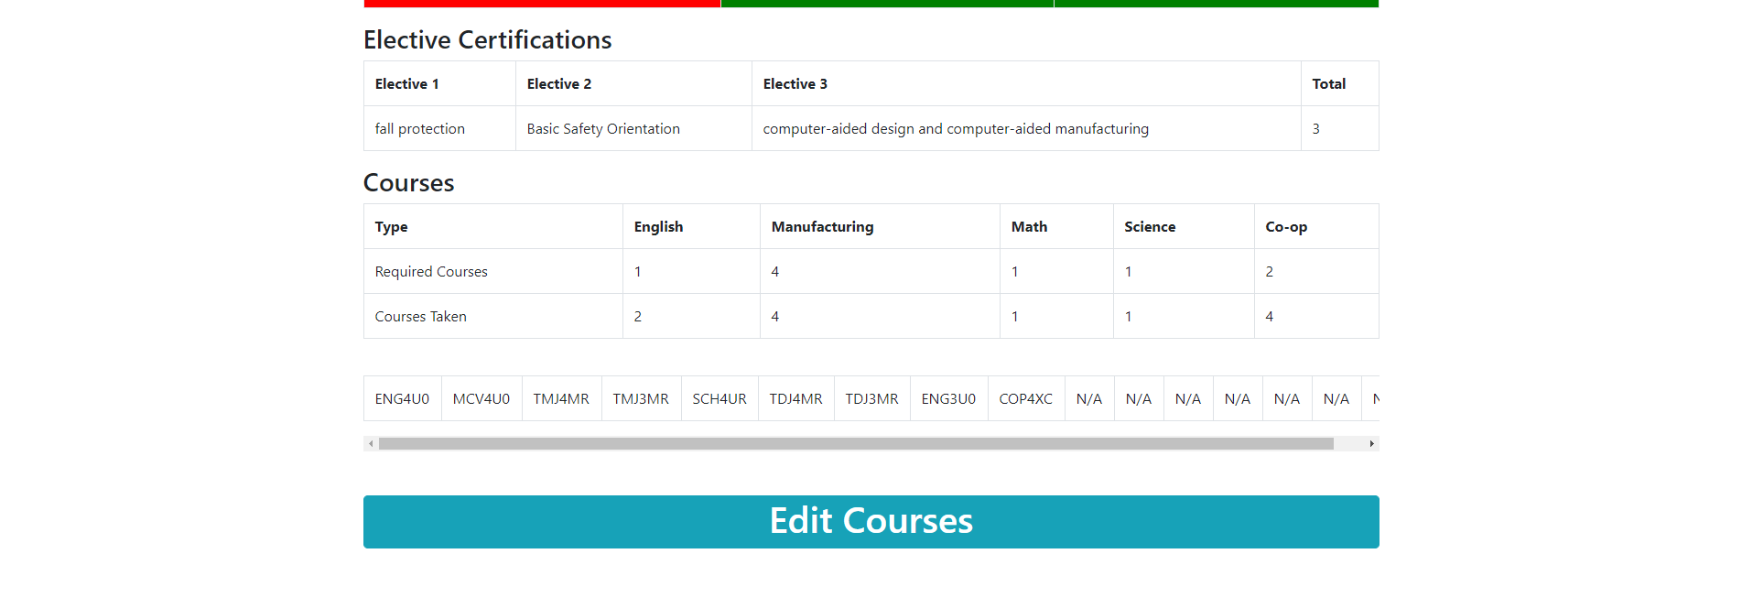

As can be seen in the image above, the student has a profile picture that can be set by the teacher. The student also has three columns in their first table, these cells when they are all green mean that a student is set and ready for finishing the SHSM program .The next table lists all the mandatory certifications required for their program, a teacher can edit these and certify that a student has completed a mandatory certification. Then there are elective certifications students have to take a certain amount of elective certifications and the program teacher can also set these. Finally there are courses that SHSM students have to take and categories that they fit into, students can set their courses, students were given the ability as if there are 200 students in the SHSM program it would be nigh impossible for the program teacher to do this.

Teacher

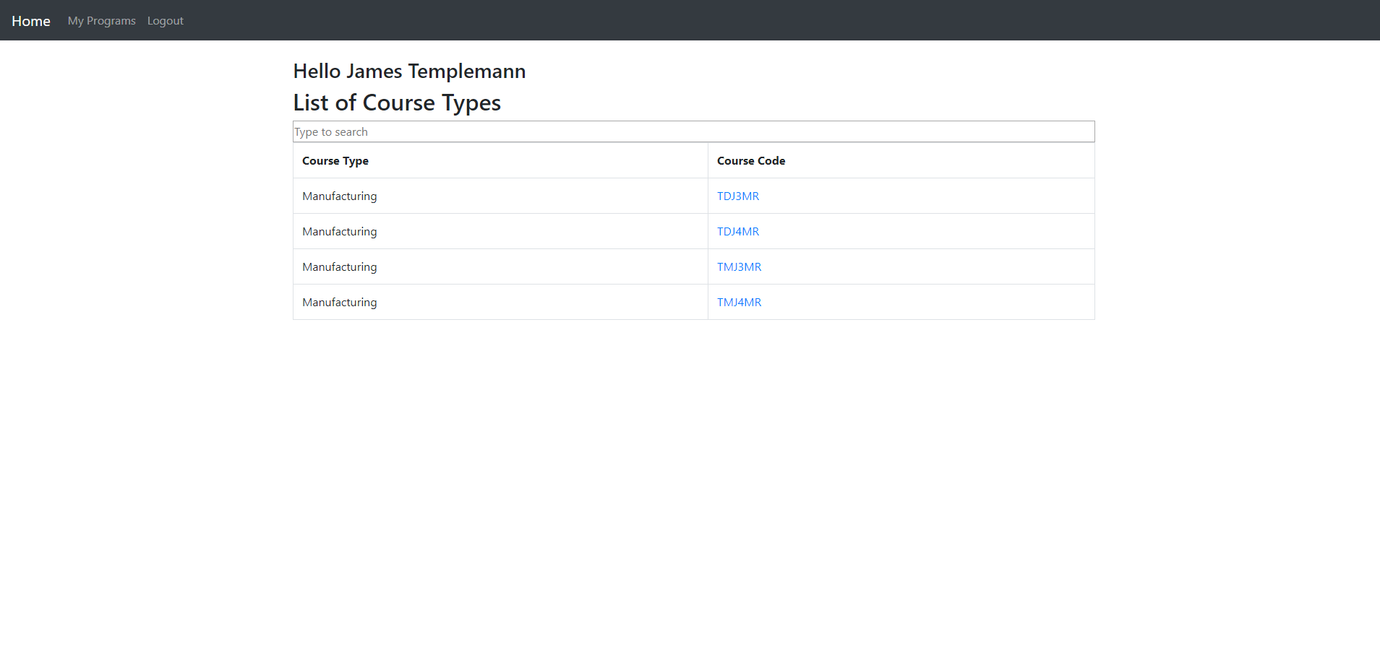

As a Teacher the teacher can view the courses that apply to their program, they can then click my programs tab to view all the programs they have access to.

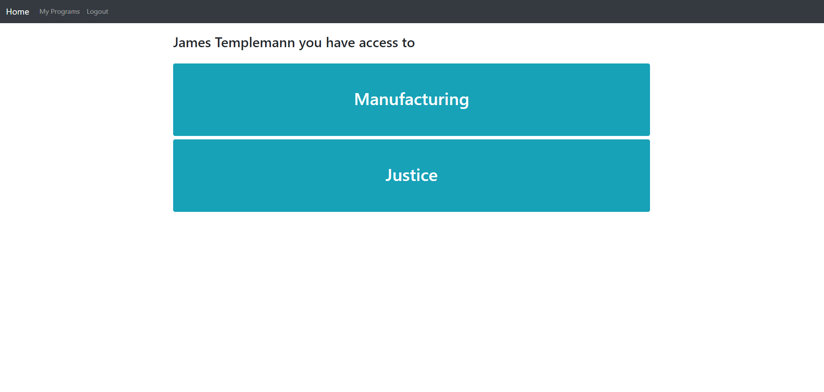

The Teachers can view all the programs however teachers can edit the programs they have permissions for.

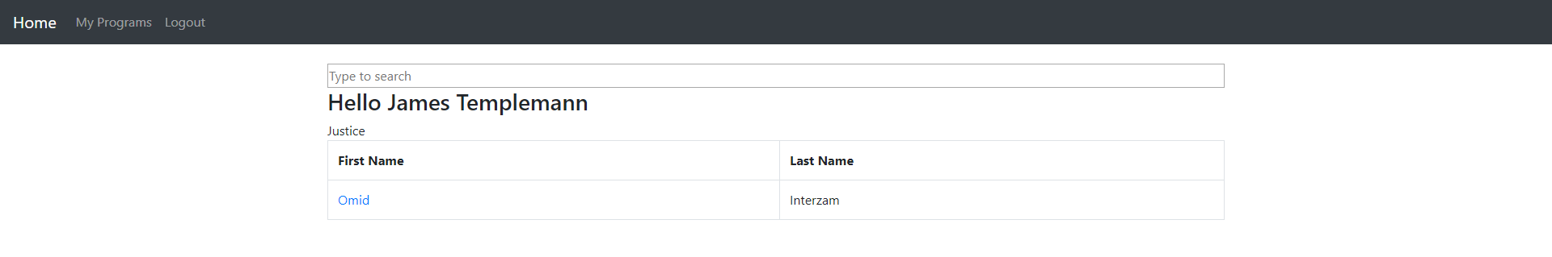

If a teacher does not have permissions to edit for this program they can see only a list of the students and cannot edit the program itself.

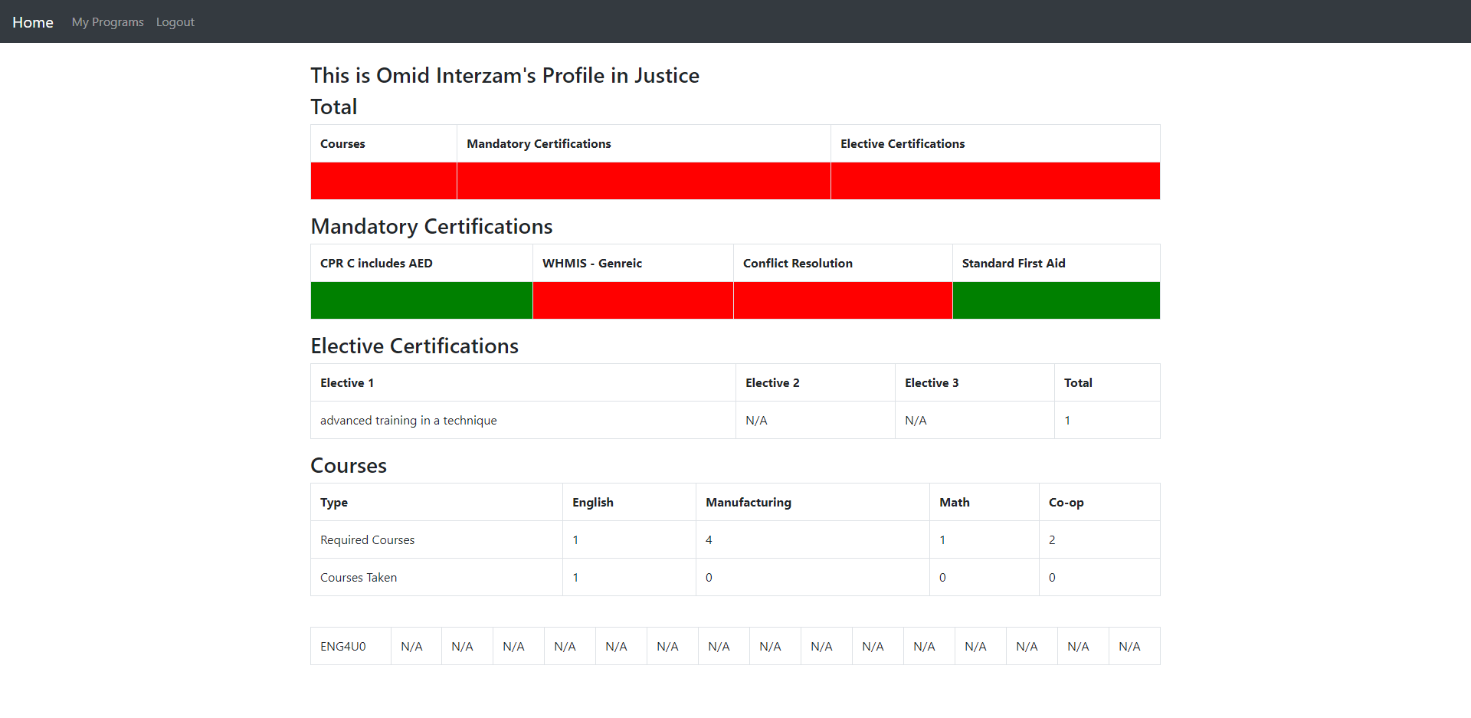

The teacher from the image above does not have access to the justice program so they can view this student’s progress in their program but cannot edit any of their data.

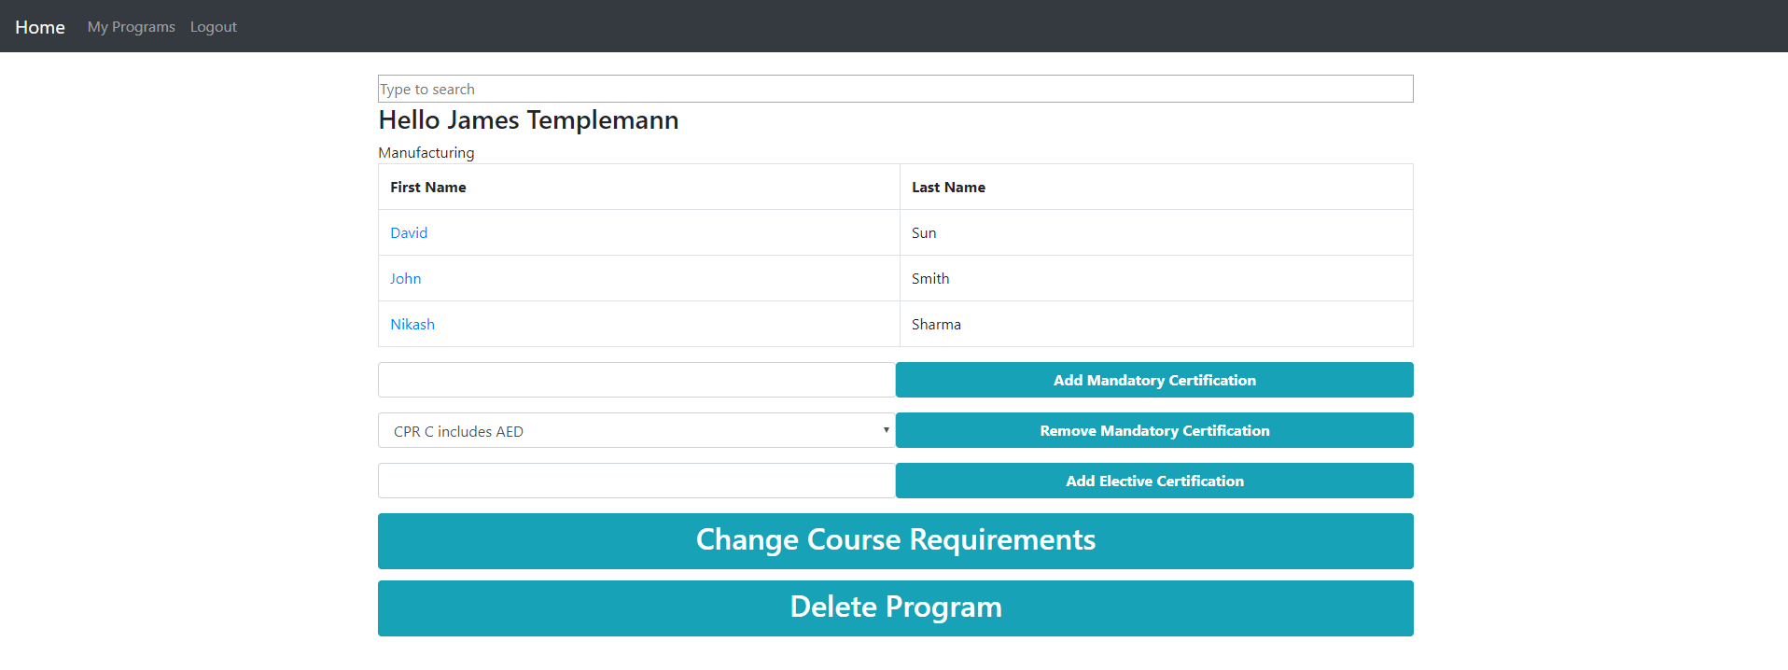

If the teacher has permissions to edit the program then they now have extra features which they can use to alter the program. The teacher can add new mandatory certifications, they can remove mandatory certifications and can add an elective certification. The teacher can also delete this program. If the teacher clicks change course requirements, then it shows the image below.

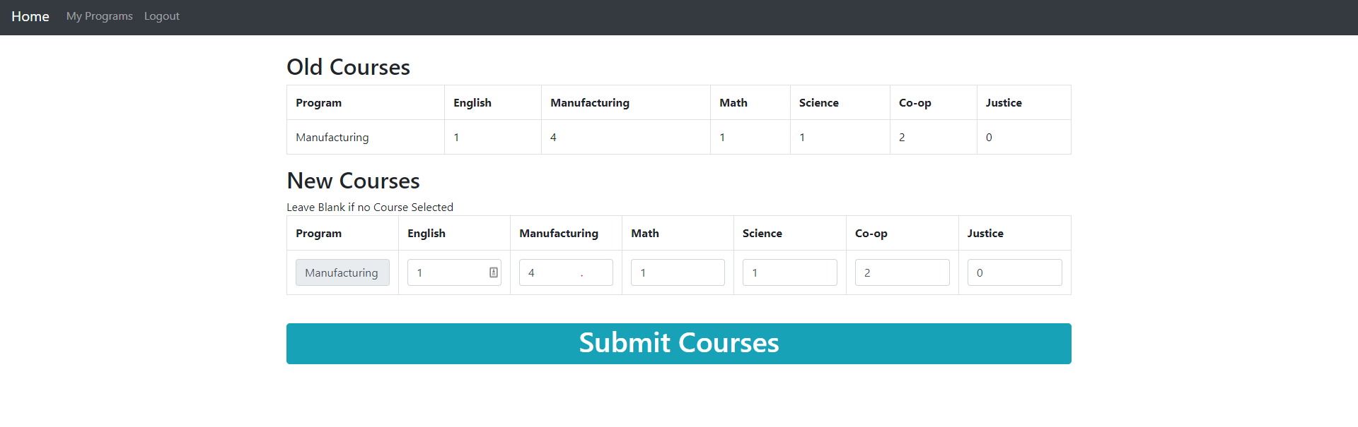

The teacher in this section can now set which courses are required for the specified SHSM program.

If a program teacher clicks on a student then they get the student’s profile with added abilities. 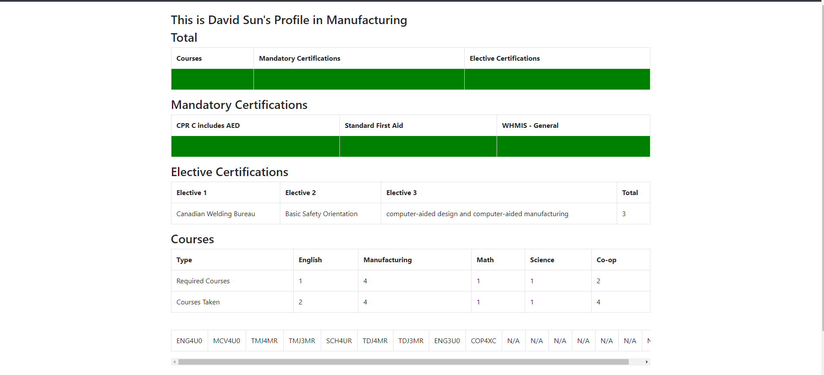

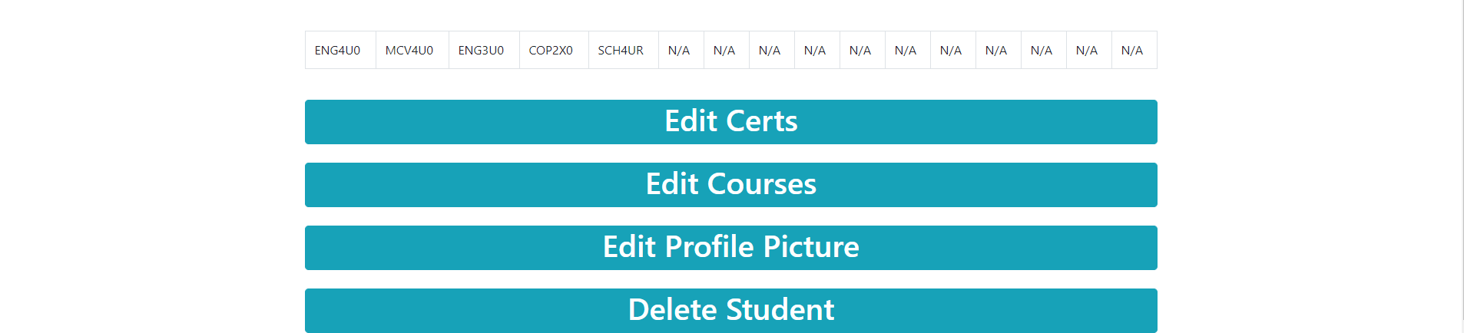

The teacher then has three buttons, edit certs, edit courses and delete student, if the teacher presses delete student they are given a prompt and then the student is deleted. If the teacher clicks the edit certs button it brings them to the page below

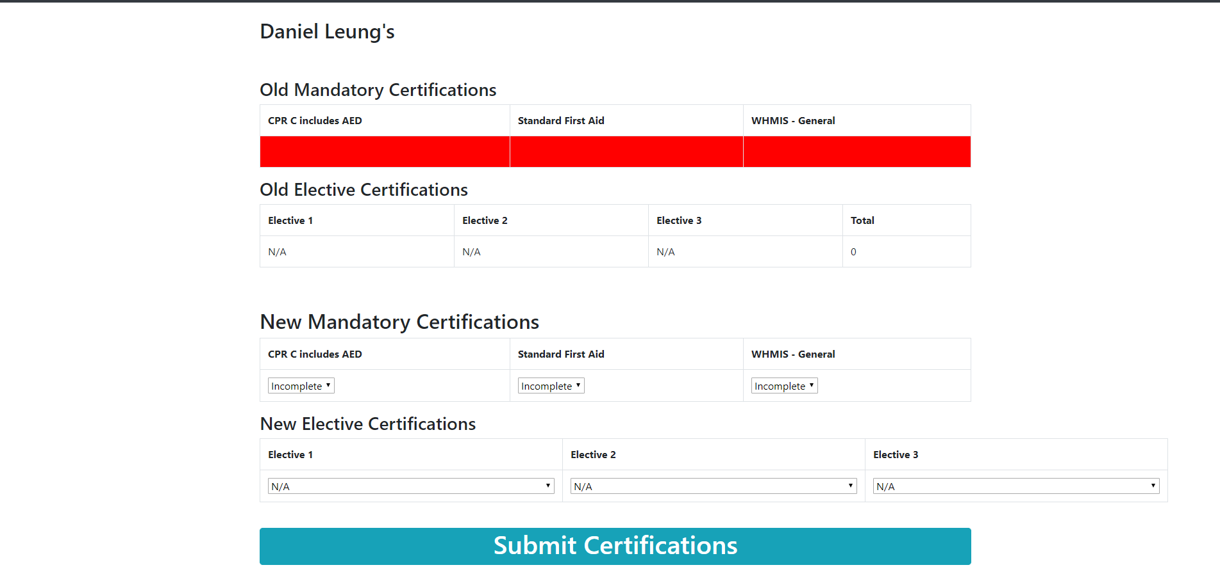

On this edit certs page the teacher can edit the certification info of the student, so the teacher can say this student has completed this certification and then submit that information.

The teacher can also select edit courses on the student profile page and it will bring them to the page below.

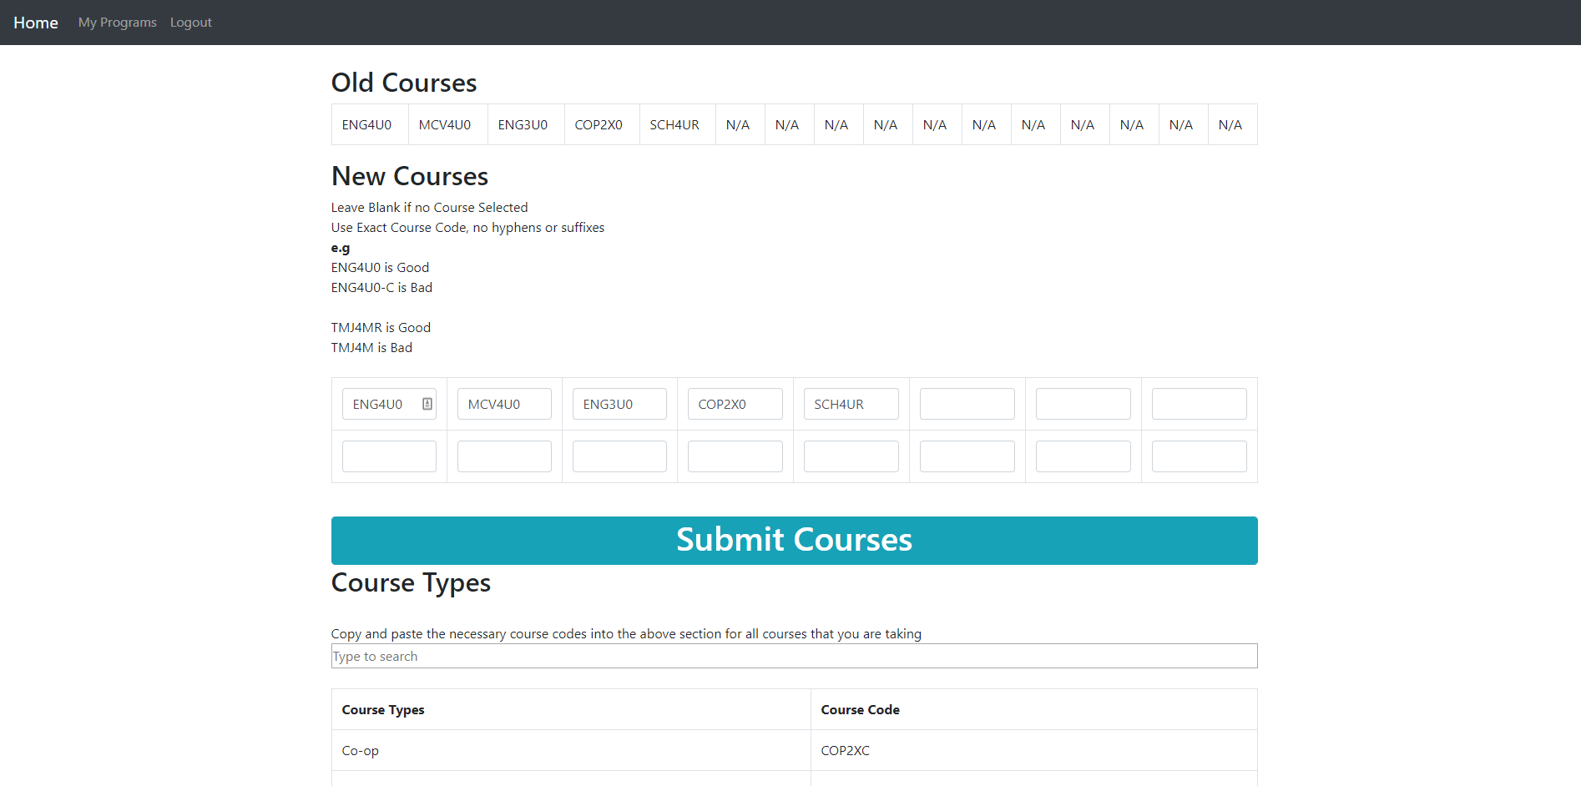

On this page the teacher can view the courses that a student is taking and edit them just like as student can. The teacher also has easy access with a search bar to see all the courses that they can pick and shows what these course codes represent to the program. 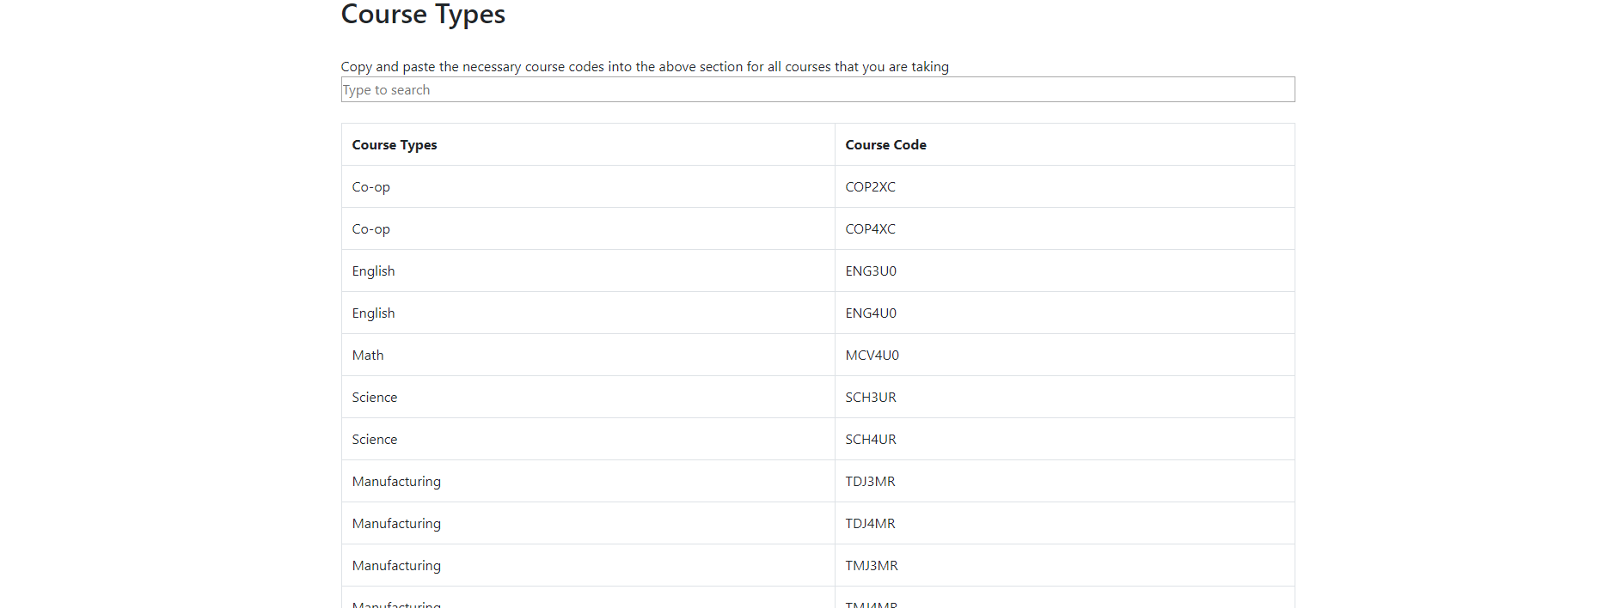

Finally the teacher can select the edit profile picture button

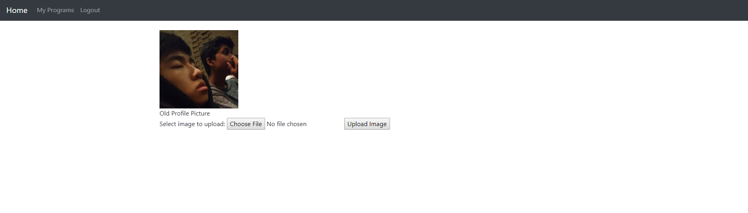

On this page the teacher can upload a profile picture for each student so they can better remember who each student is. The teacher presses choose file which will bring up a file select menu and then they press upload image and it will set the student’s profile picture to that image.

**Admin**

The admin has all the abilities of a teacher however has some added functionality, the majority of which is on the admin’s home page.

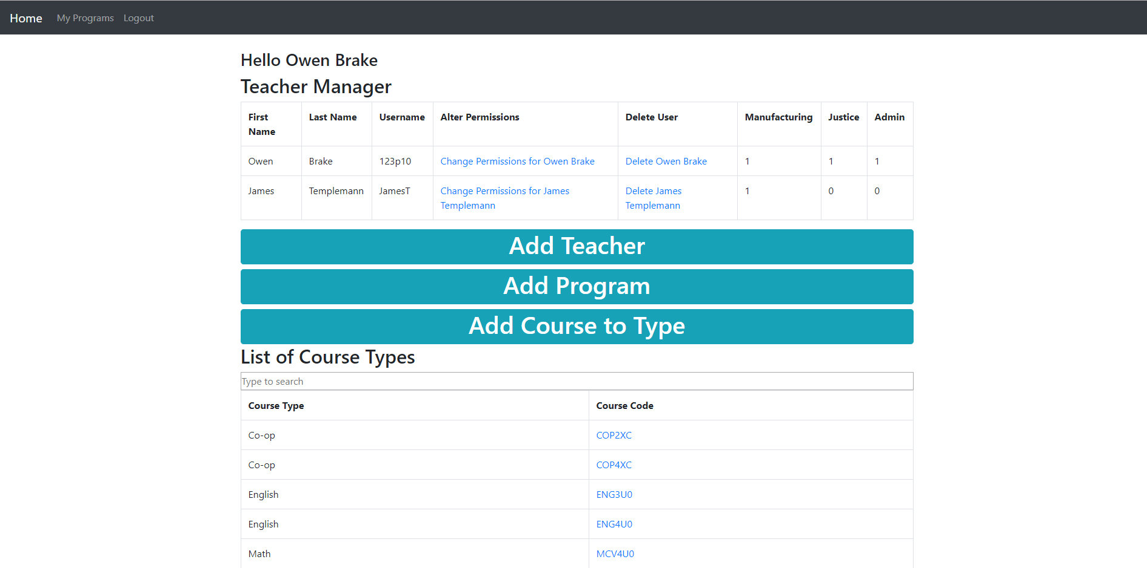

The admin has a lot more added functionality to their home page. The admin can manage all the teachers and their permissions. The admin in the table can click the delete link and it will delete that user. The admin can click the change permissions and it will bring them to the page below.

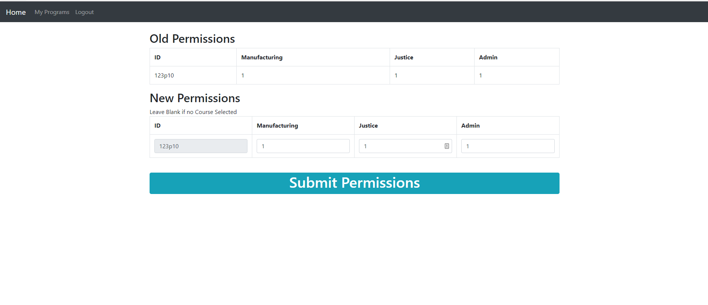In the permissions table the admin can edit which permissions a teacher has access to, they can set what a teacher has access too.

In the admin home page the admin can also add a teacher when the admin clicks the button it will bring them to a new page. 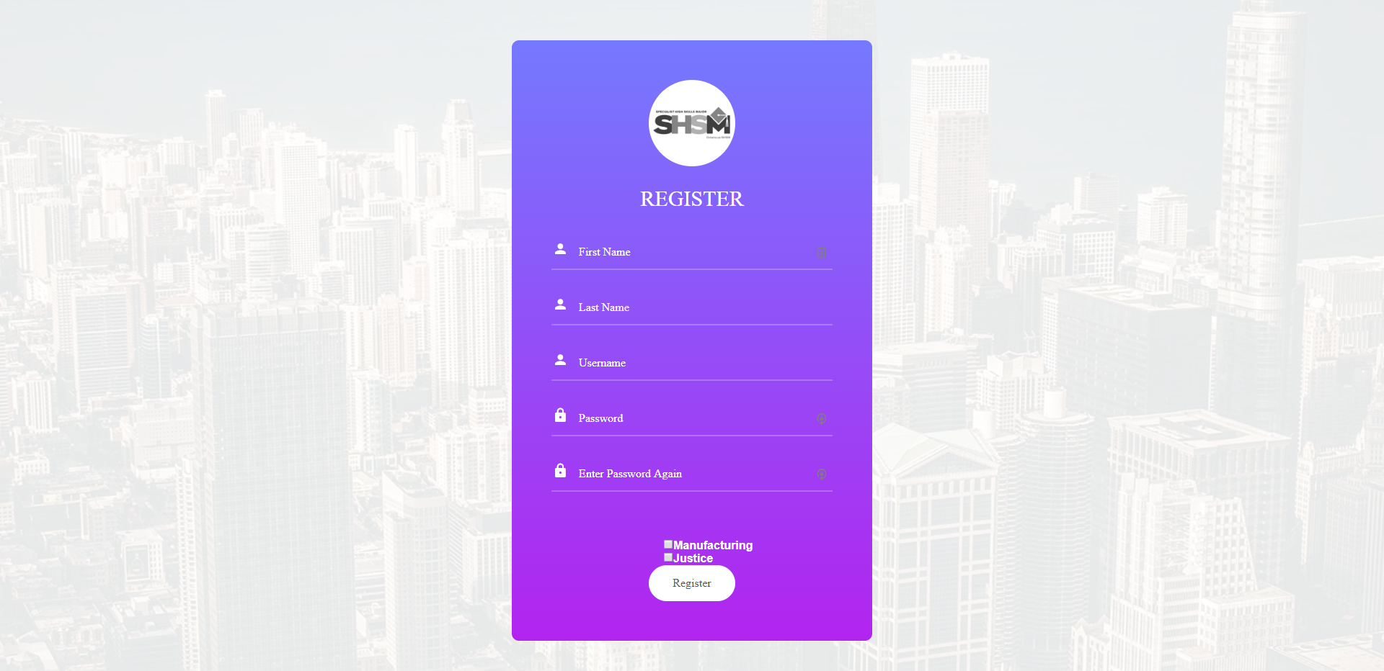

The admin can insert a teacher’s information and add them to the database.

Another thing in the admin page is the add program button. When it is clicked it redirects them to the page seen below.

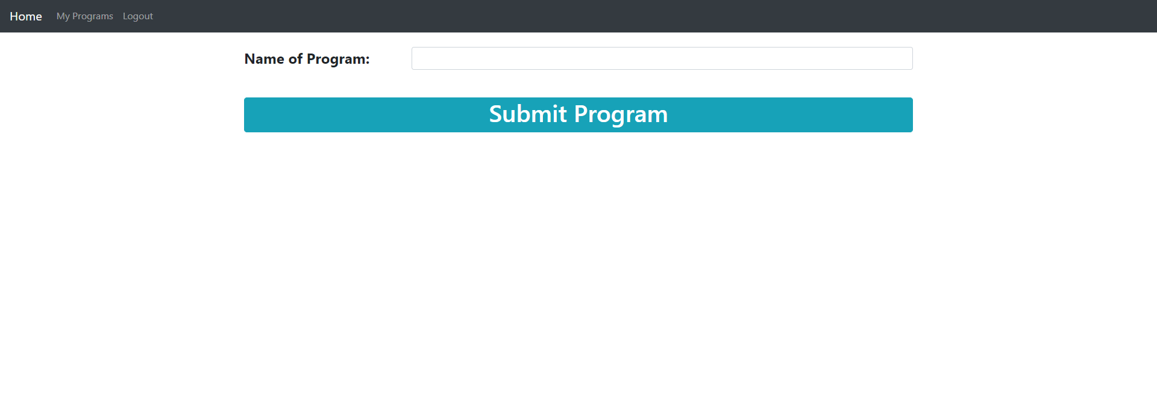

The add program button only has one element because the system is so modular. All that is required to make a new program is the name, the admin can then go back and set how many mandatory certifications a student should have, what courses they can take and all the requirements for a program.

In the admin page there is also an add course type button. When it is clicked it redirects the admin to the page seen below.

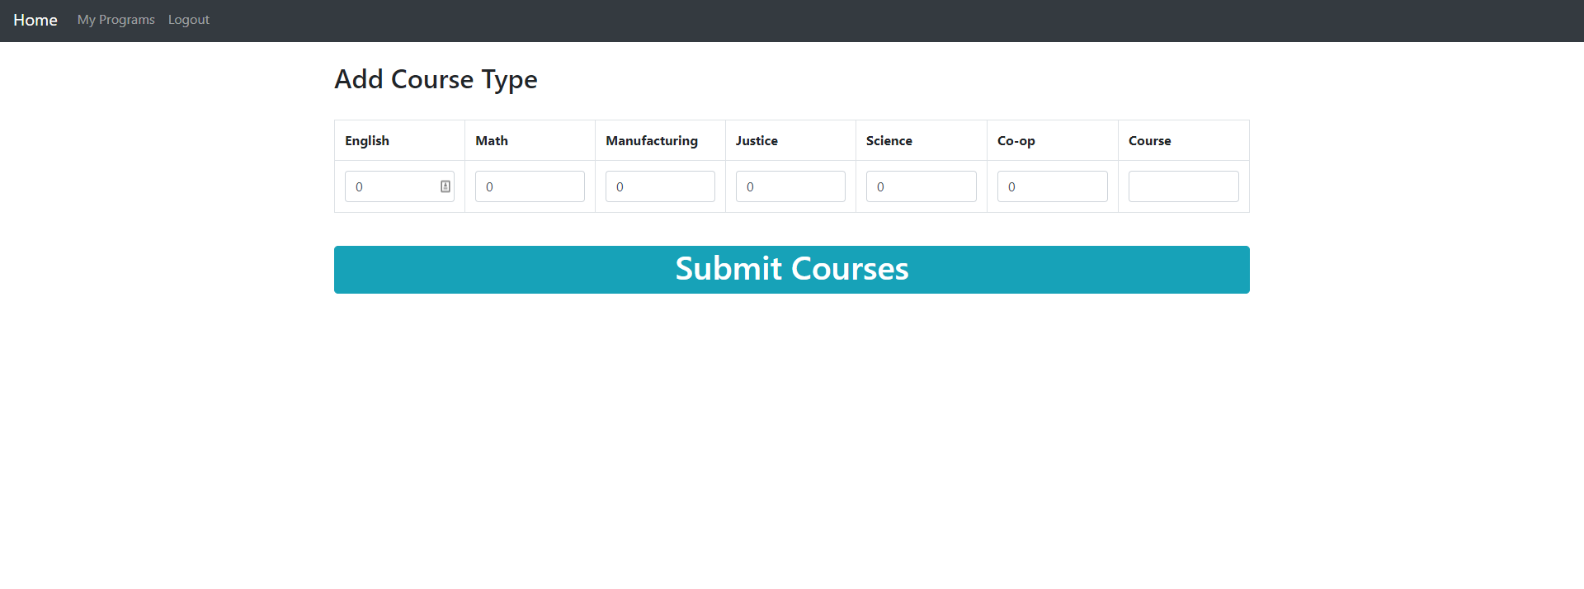

In this page the admin can add a course and establish what that course means to the program, for example some programs require a science but the system does not understand what courses are science courses so the admin can input in Course SCH4U and type 1 under science and the SCH4U course will be treated as one science credit if a student has that course in their profile.

**Log**

